Subject Name:Software Engineering with Data Analytics

Subject code:CSA1002

Name: B.Soma Sekhar

Register No:192211147

1.Draw a USE-CASE diagram for Online voting System using CASE tools

Aim:To draw a use case diagram for online voting system

Software Used:Umbrello

Diagram:

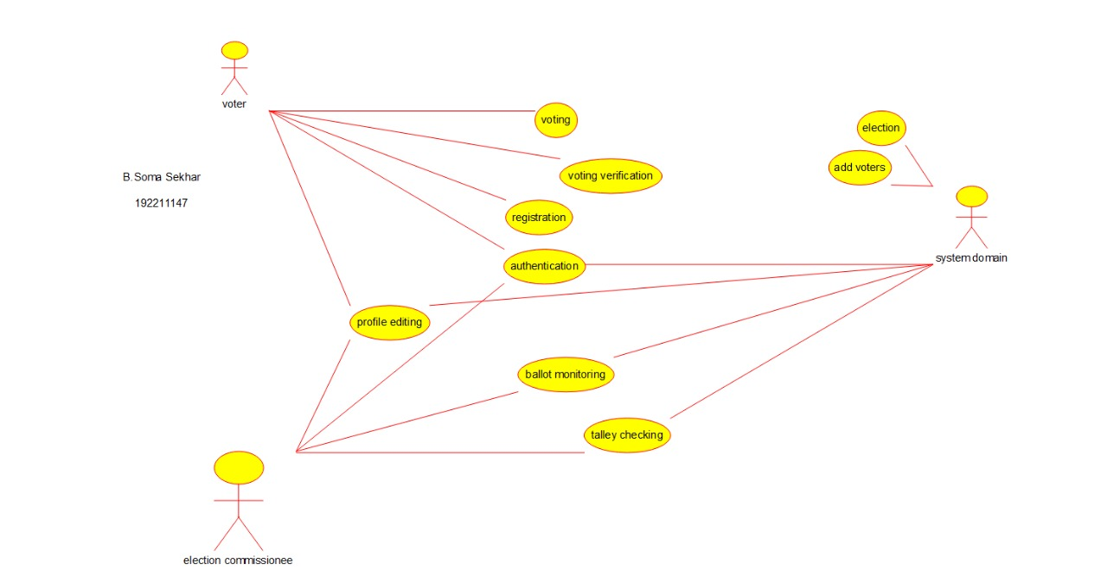

Result:Use_ case diagram for online voting system was successfully completed

2.Draw a USE-CASE diagram for Library Management System using CASE tools.

Aim:To draw a use case diagram for library management system

Software Used:Umbrello

Diagram:

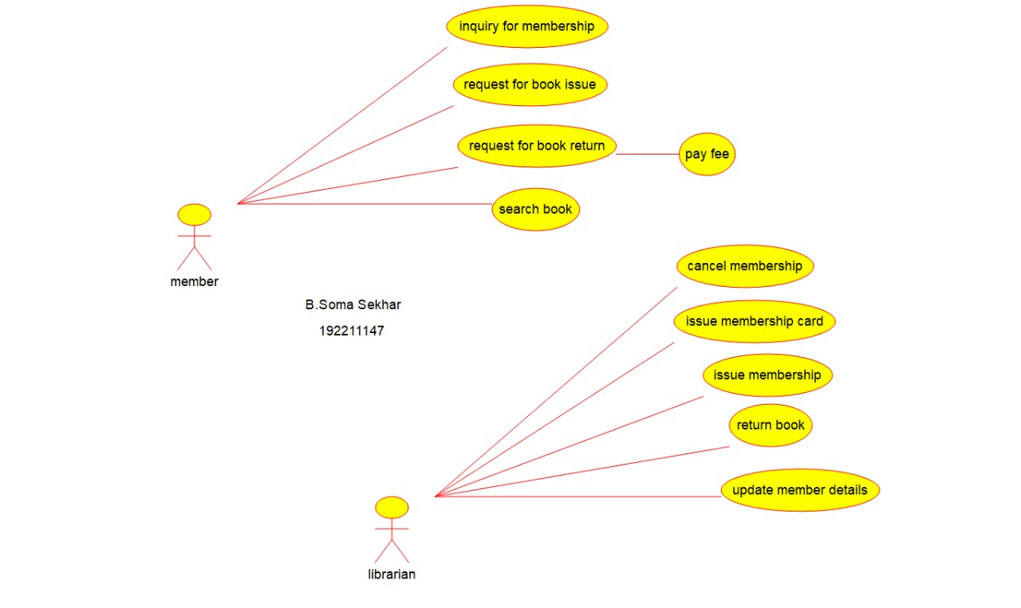

Result:Use case diagram for library management system was successfully completed

3..Draw and validate the flowchart to compute the quotient and remainder

Aim:To draw a raptor flow chat to compute the quotient and remainder

Software Used: Raptor

Diagram:

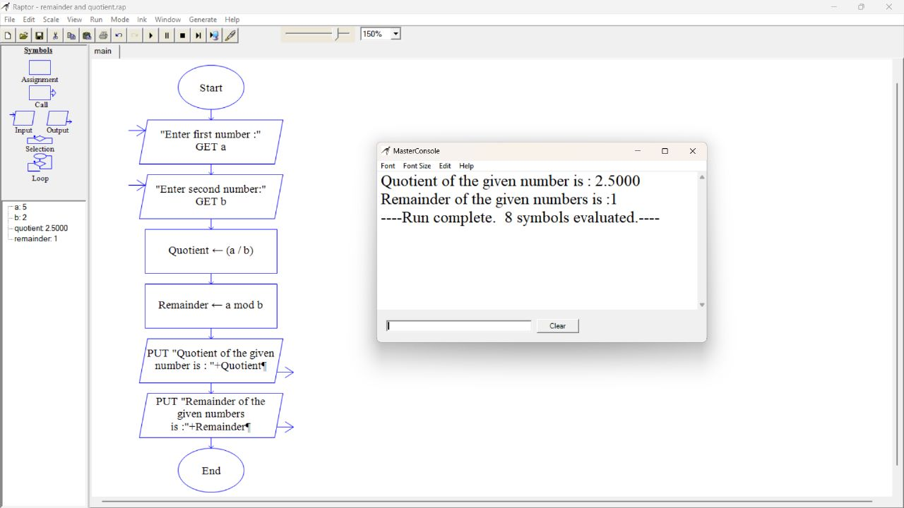

Result: Raptor for compute the quotient and remainder was successfully completed and output verified

4. Draw a USE-CASE diagram for Online Shopping system using CASE tools.

Aim:To draw a use case diagram for online shopping system

Software Used: Umbrello

Diagram:

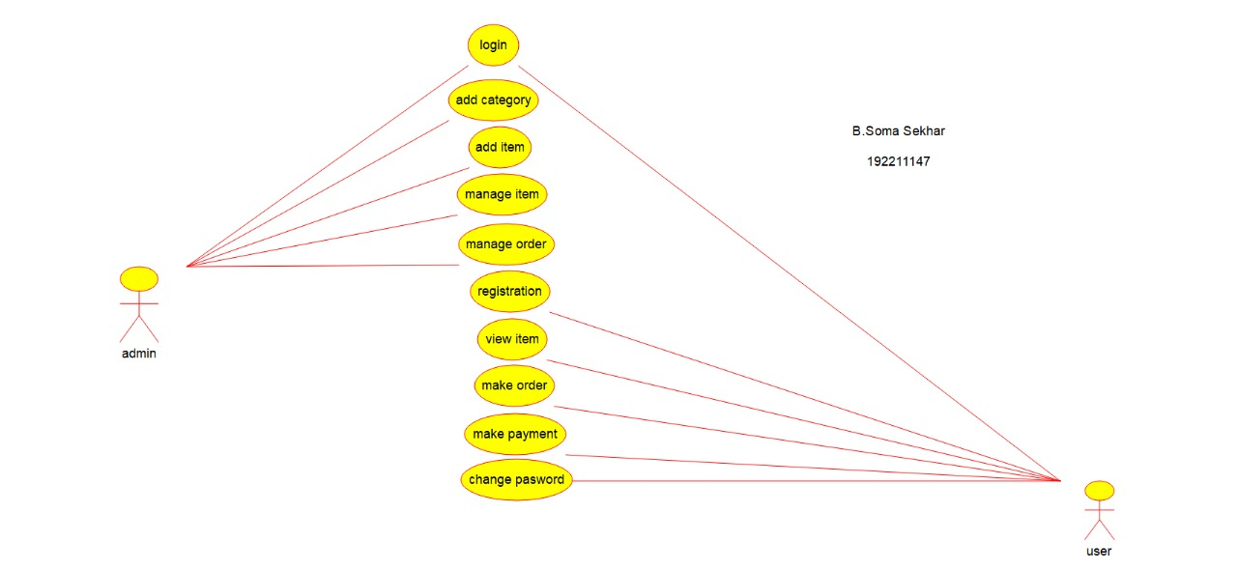

Result:Use case diagram for online shopping system was successfully completed

5.Draw a USE-CASE diagram for Online Railway Reservation System using CASE tools.

Aim: To draw a use case diagram for online railway reservation system

Software Used: Umbrello

Diagram:

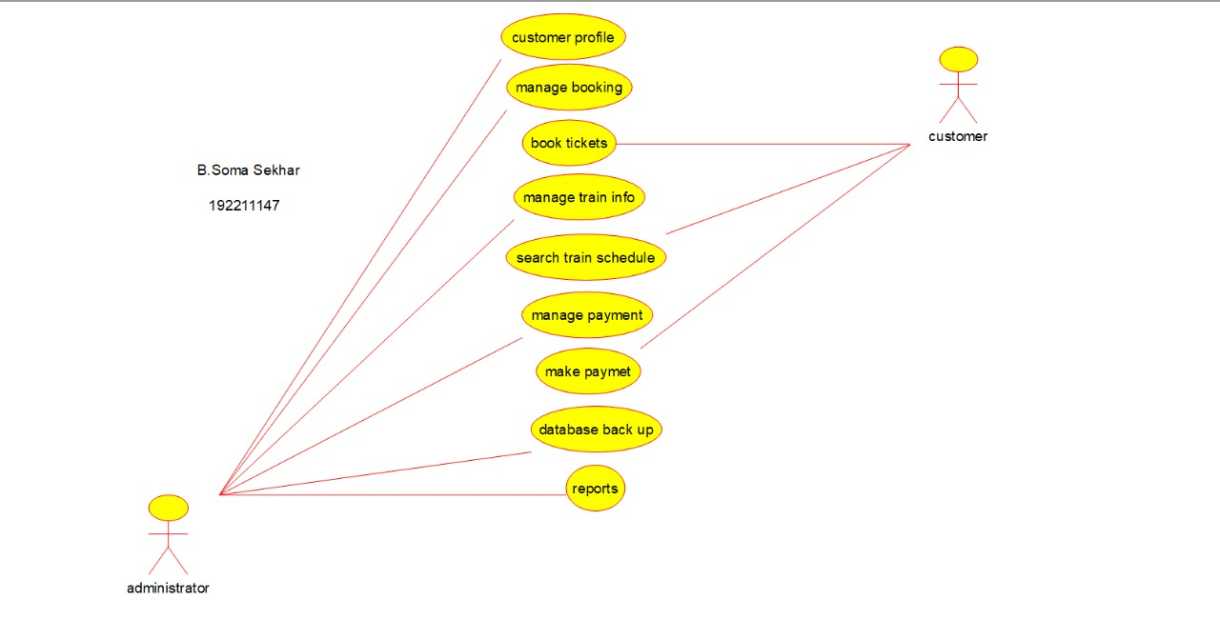

Result:Use case diagram for online railway reservation system was successfully completed

6 Draw a USE-CASE diagram for Hospital Management System using CASE tools.Aim: To draw a use case diagram for hospital management system

Software Used: Umbrello

Diagram:

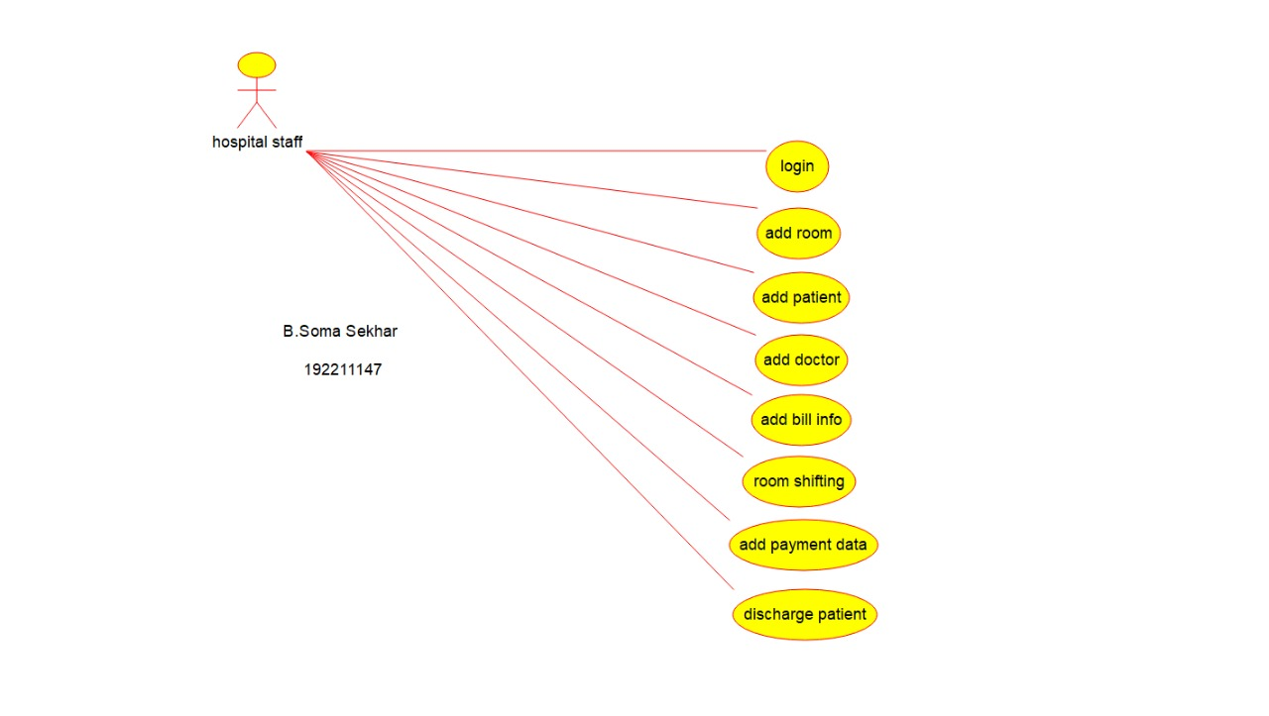

Result:Use case diagram for hospital management system was successfully completed

7.Draw a USE-CASE diagram for ATM System using CASE tools.

Aim :To draw a use case diagram for ATM system

Software Used: Umbrello

Diagram:

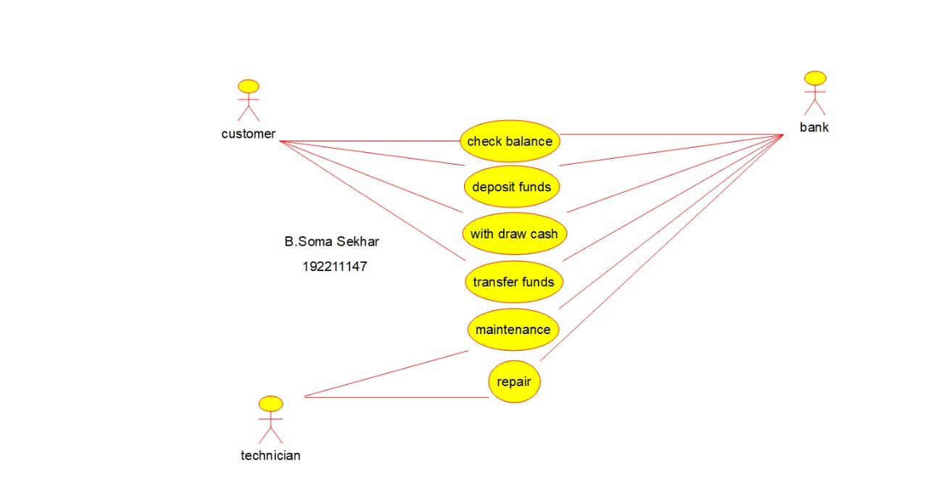

Result:Use case diagram for ATM system was successfully completed

8.Draw a USE-CASE diagram for Online college management System using CASE tools

Aim:To draw a use case diagram for online college management system

Software Used: Umbrello

Diagram:

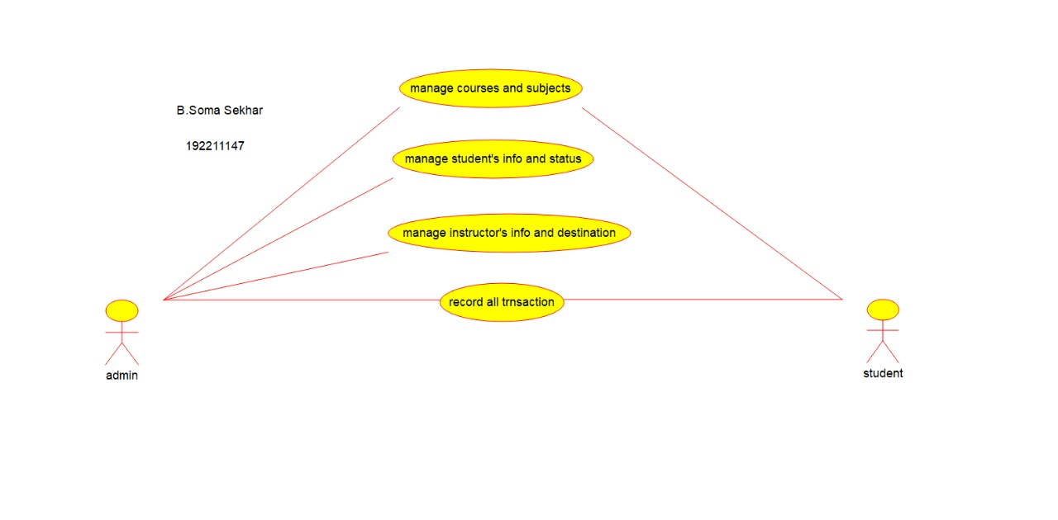

Result: use case diagram for online college management system was successfully completed

9.Draw a USE-CASE diagram for Online Airline Reservation System using CASE tools

Aim: To draw a use case diagram for online airline reservation system

Software Used: Umbrello

Diagram: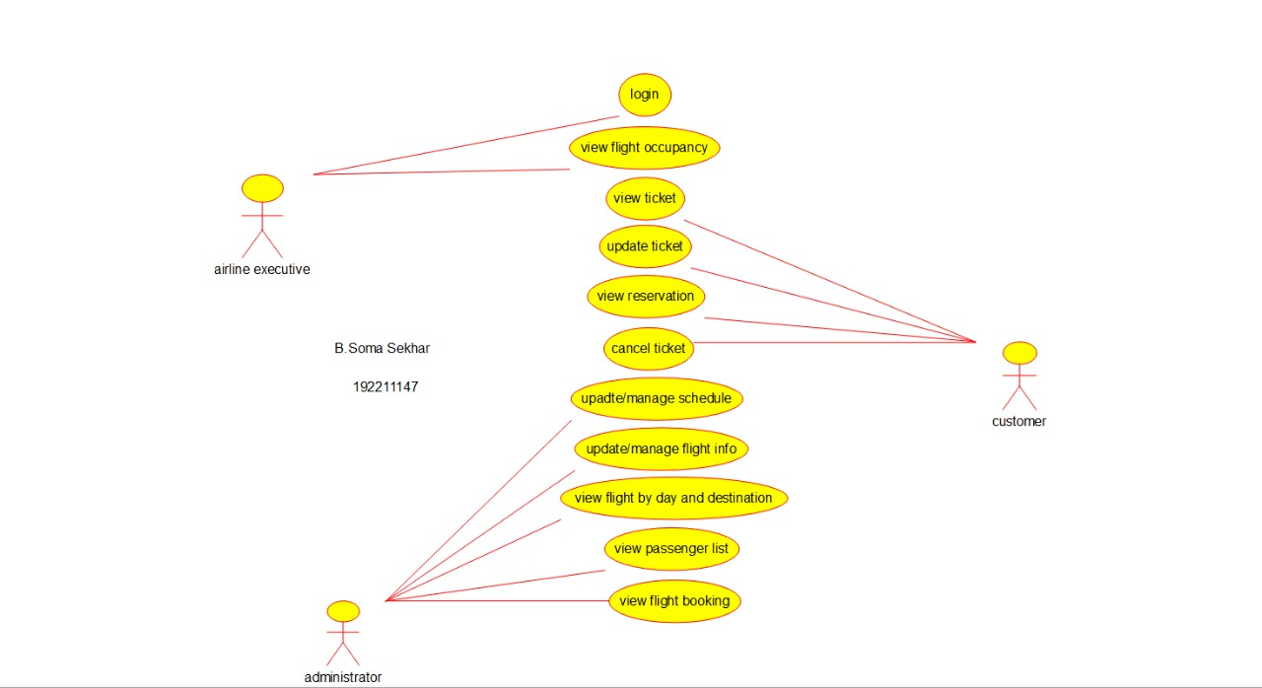

Result:Use case diagram for online airline reservation system was successfully completed

10.Draw a Class diagram for Online Airline Reservation System using CASE tools

Aim:To draw a class diagram for online airline reservation system

Software Used: Raptor

Diagram:

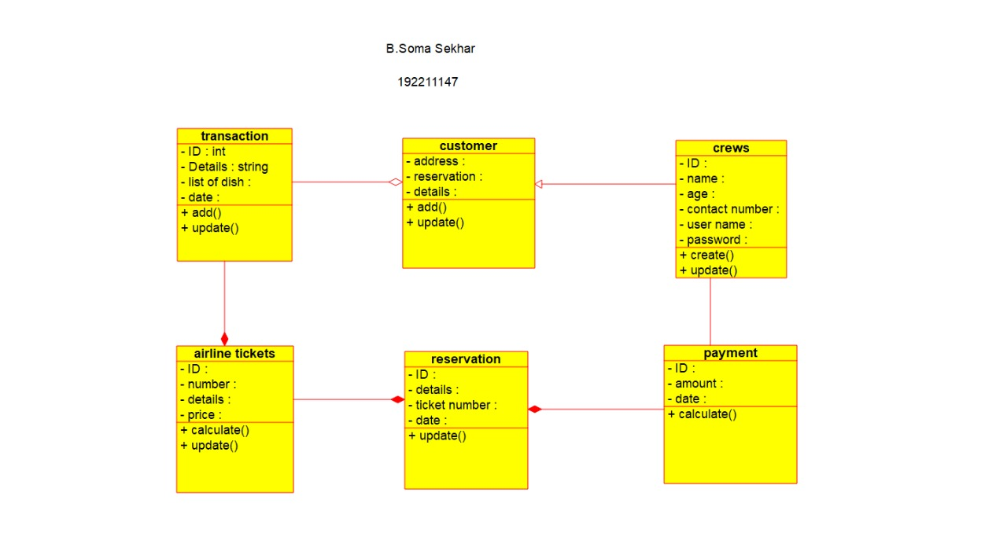

Result: Class diagram for online airline reservation system was successfully completed

11.Draw a Class diagram for Online Voting System using CASE tools

Aim: To draw a class diagram for online voting system

Software Used: Umbrello

Diagram:

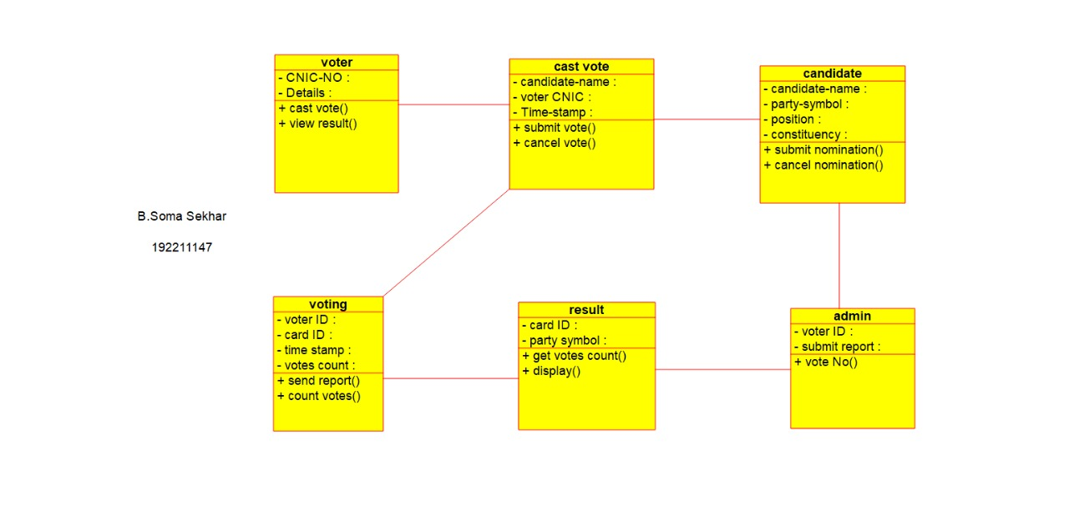

Result: Class diagram for online voting system was successfully completed

12.Draw a Class diagram for Library Management System using CASE tools.

Aim:To draw a class diagram for library management system

Software Used: Umbrello

Diagram:

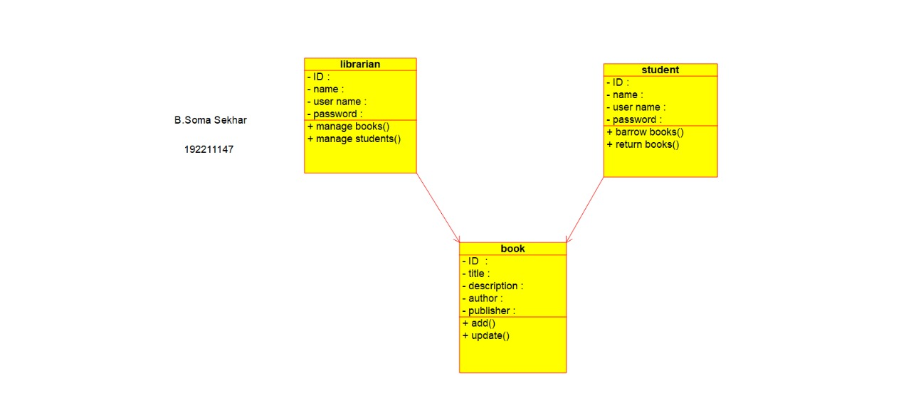

Result: Class diagram for library management system was successfully completed

13.Draw a Class diagram for Online Shopping system using CASE tools

Aim: To draw a class diagram for online shopping system

Software Used: Umbrello

Diagram:

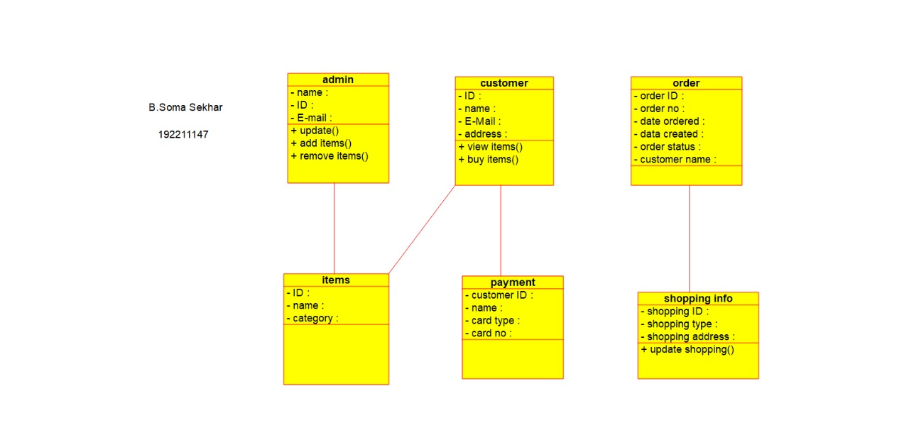

Result: Class diagram for online shopping system was successfully completed

14.Draw a Class diagram for Online Railway Reservation System using CASE tools

Aim: To draw a class diagram for railway reservation system

Software Used :Umbrello

Diagram:

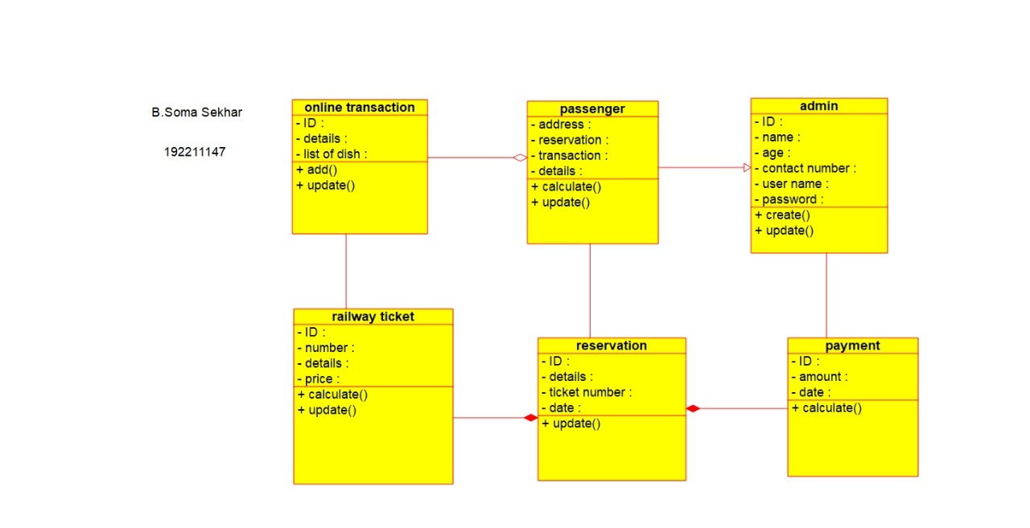

Result: Class diagram for online railway reservation system was successfully completed

15.Draw a Activity diagram for Online Voting System using CASE tools

Software Used: Umbrello

Diagram:

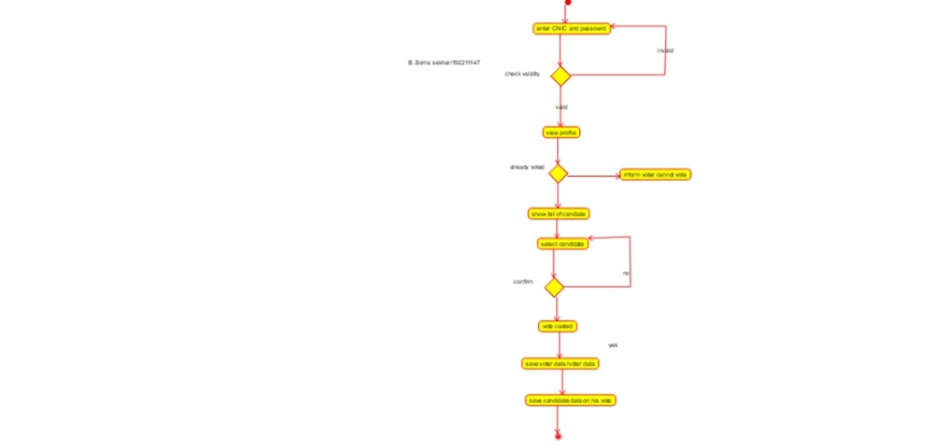

Result: Activity diagram for online voting system was successfully completed

16.Draw a Activity diagram for Library Management System using CASE tools

Aim:To draw a activity diagram for library management system

Software Used: Umbrello

Diagram:

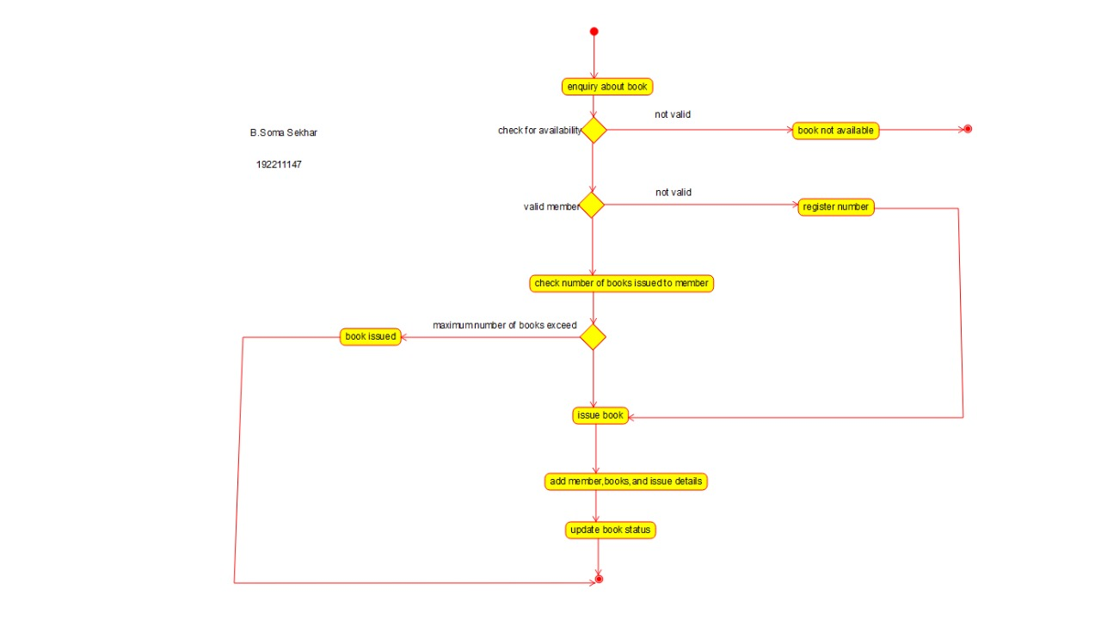

Result: Activity diagram for library management system was successfully completed

17.Draw a Activity diagram for Online Shopping system using CASE tools.Aim:To draw a activity diagram for online shopping system

Software Used: Umbrello

Diagram:

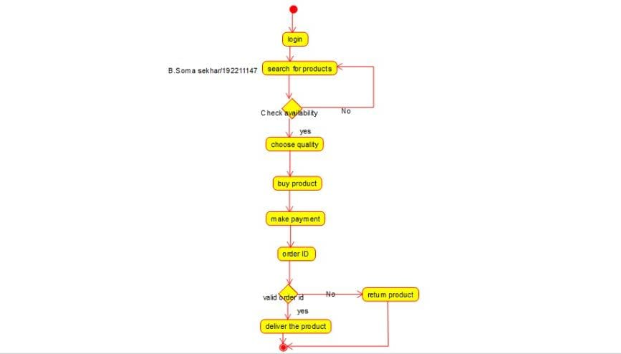

Result: Activity diagram for online shopping system was successfully completed

18.Draw a Activity diagram for Online Railway Reservation System using CASE tools.

Aim:To draw a activity diagram for online railway reservation system

Software Used: Umbrello

Diagram:

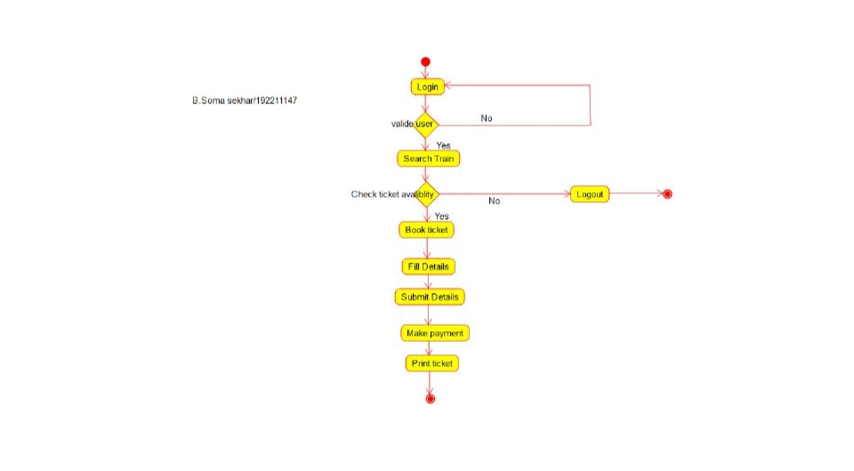

Result: Activity diagram for online railway reservation system was successfully completed

19.Draw a Activity diagram for Hospital Management System using CASE tools

Aim:To draw a activity diagram for hospital management system

Software Used: Umbrello

Diagram:

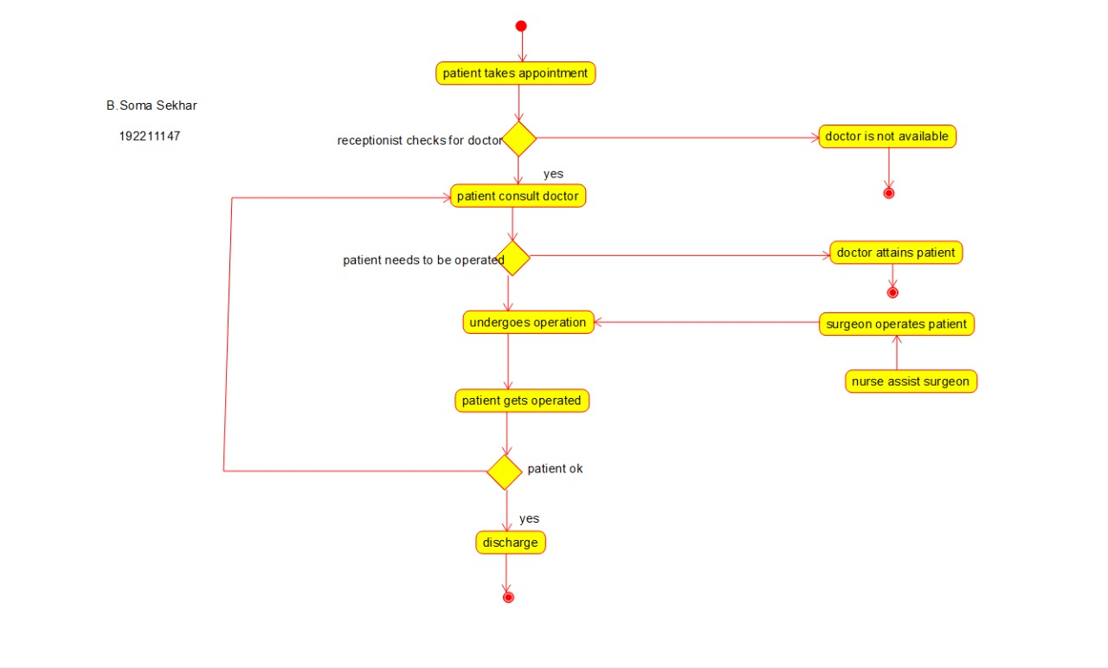

Result: Activity diagram for hospital management system was successfully completed

20Using Raptor- Draw the flowchart to check whether the given number is a palindrome or not.

Aim:To check whether the given number is palindrome or not

Software Used: Raptor

Diagram:

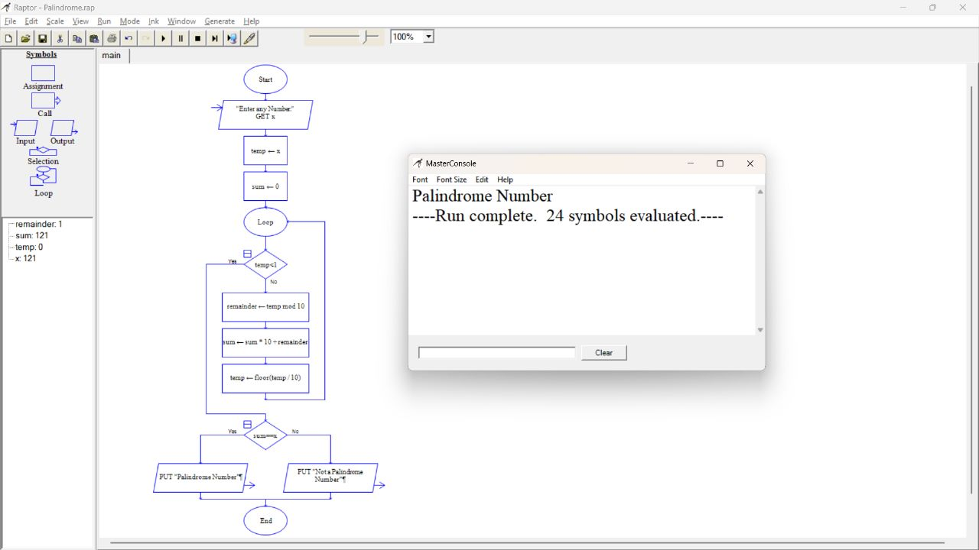

Result:Flow chart to check whether the given number is palindrome or not was successfully completed and output verified

21.Using Raptor- Draw and validate the flowchart to calculate Fibonacci series.Aim:To draw a raptor draw and validate the flowchart to calculate Fibonacci series

Software Used: Raptor

Diagram:

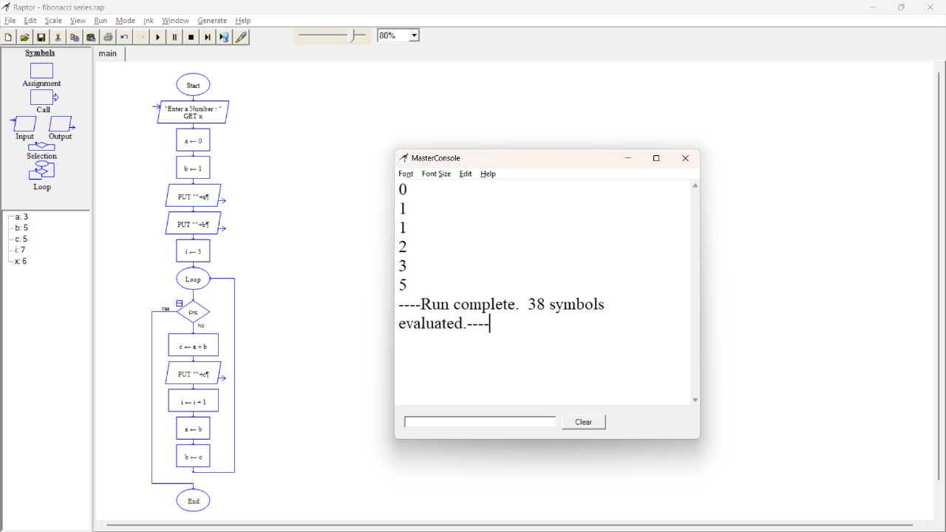

Result: Flow chart to calculate Fibonacci series was successfully completed and output verified

22.Using Raptor – Draw and validate the flowchart to swap two characters.

Aim:To draw a raptor draw and validate the flowchart to swap two characters

Software Used: Raptor

Diagram:

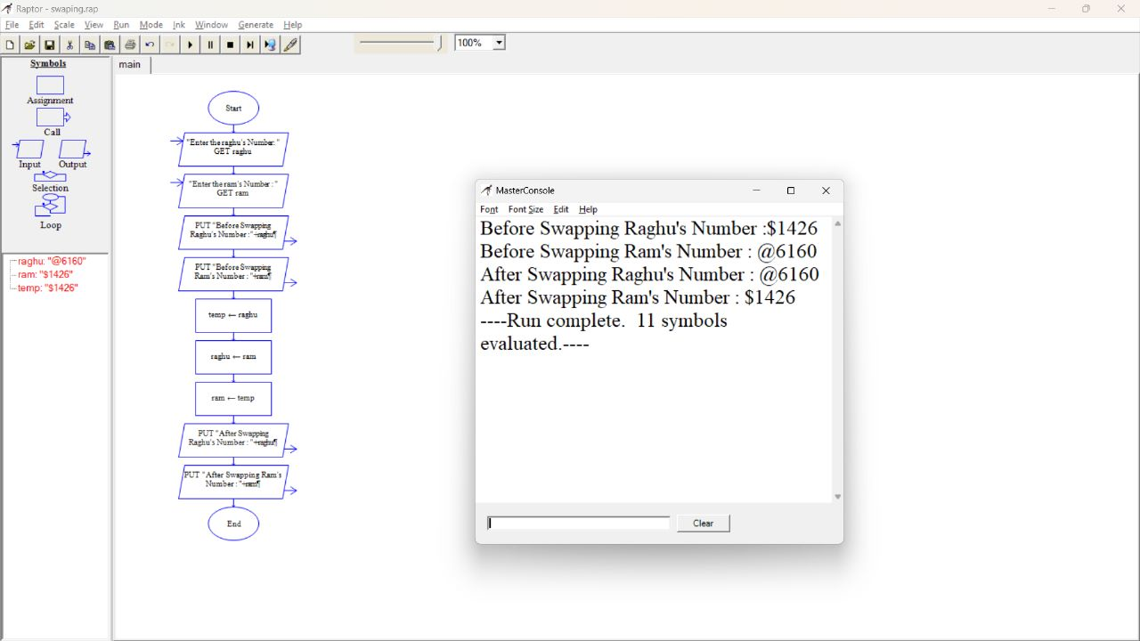

Result: Flow chart to swap two characters was successfully completed and output verified

23.Using Raptor – Draw the flowchart to display the length of the string.

Aim: To draw raptor for flow chat to display the length of the string

Software Used: Raptor

Diagram:

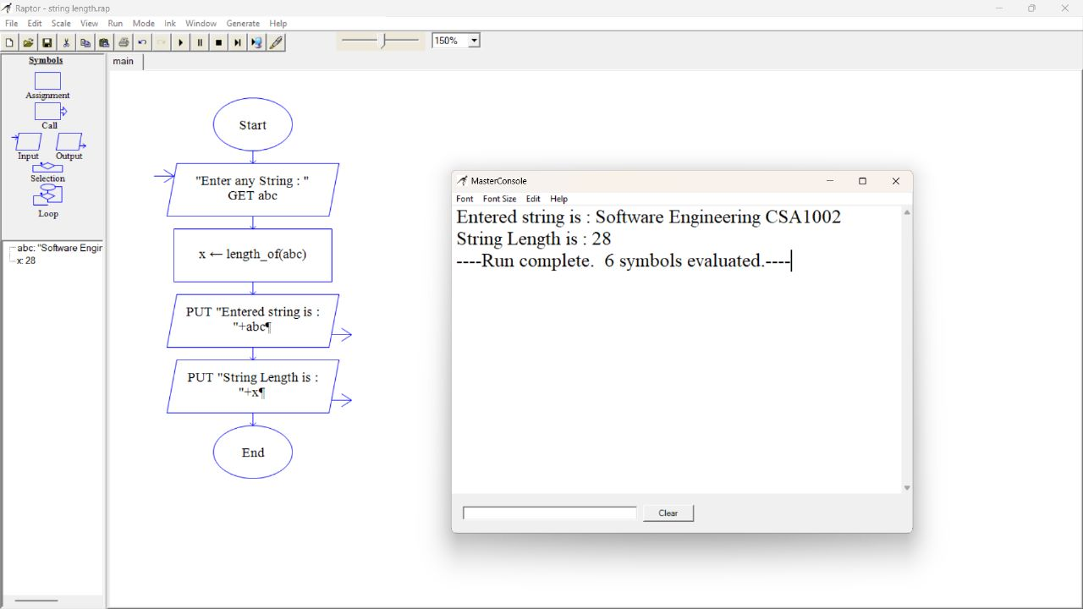

Result: Flow chart to display the length of the string was successfully completed and output verified

24.Using Raptor – Draw the flowchart to find whether the given number is prime or not.

Aim: To draw a raptor diagram the flow chart whether the given number is prime or not

Software Used: Raptor

Diagram '

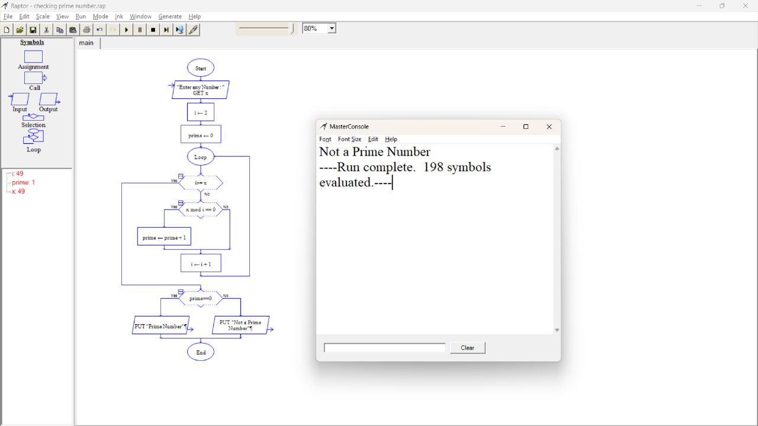

Result: Flow chart whether the given number is prime or not was successfully completed and output verified

25.Find Cyclomatic Complexity for a graph having number of edges as 17, number of nodes as 13 and number of predicate nodes in the flow graph as 5.

Diagram:

